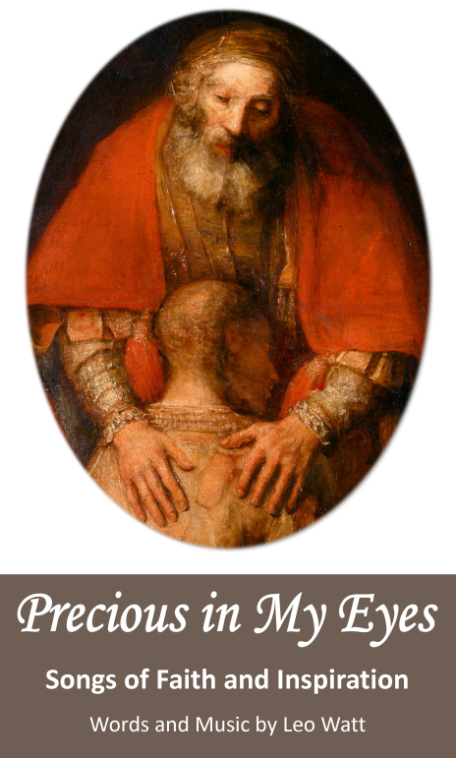

For copyright protection, all hymns are listed with  
**Onelicense.net** and also with **CCLI** for Congregational use and are included in your license if you have signed up with them.

**Themes/Seasons**

*God’s love*

*Response to readings*

*Processional*

*Good Friday*

*Entrance /Recessional*

*Mission/ Funerals*

*Entrance*

*Funerals*

*Lent/Reconciliation/Advent*

*Good Friday*

*Weddings*

*Eucharist*

*Good Friday meditation*

*Easter*

*Recessional*

**Titles**

*Precious in my eyes*

*Listen to my Word*

*No greater love*

*Song of my people*

*Because of You*

*You are welcome*

*Into Paradise*

*I wait for you*

*Calvary*

*When Love is there*

*Take this bread and cup of wine*

*They know not what they do*

*The Lord is risen*

*Go in peace to love and*

*serve the Lord*

**Themes/Seasons**

*God’s love*

*Response to readings*

*Processional*

*Good Friday*

*Entrance /Recessional*

*Mission/ Funerals*

*Entrance*

*Funerals*

*Lent/Reconciliation/Advent*

*Good Friday*

*Weddings*

*Eucharist*

*Good Friday meditation*

*Easter*

*Recessional*

**ORDER FORM**

**From:** ........................................................................................

**Address:** ..........................................................................................

**To:** Leo Watt...Troubadour Productions Australia (lrjwatt@bigpond.com)

77-83 Mackney Road, Upper Caboolture Qld 4510

( ) Copy/copies of Sheet Music Album: ***Precious in My Eyes*** $25 Includes post/pack

( ) Copy/copies of CD : ***Precious in My Eyes*** *$15 Includes postage/packaging*

( ) Copy/copies of both : $35 Includes postage/packaging

Invoice sent or direct deposit to R J Leo Watt , BSB 514 179 a/c no. 1080527

If paying by cheque. please make it out to RJ Leo Watt, ( not Troubadour Productions Aus.)

To: Parish Staff, Liturgy Committees,

Youth Groups & Musicians

*A new album of hymns for Mass and Special Occasions*

*Based on Scripture*

*Music where God speaks to us and we speak to God*

*Where we pray as an individual and as a congregation*

**Words and music by Leo Watt**

**Australian composer since his hymn**

***“Go now, you are sent forth”***